(Approx. 934 words)

Restoring Windows with the SystemRescueCD
By Dick Maybach, Member, Brookdale Computer Users’ Group, NJ
June 2015 issue, BUG Bytes
www.bcug.com
n2nd (at) att.net

We toured the Trinity Rescue Kit, a live CD-ROM system designed to correct MS Windows problems in the May 2014 BCUG Bytes (available at http://www.bcug.com). This month we'll do the same for the SystemRescueCD, http://www.sysresccd.org/SystemRescueCd_Homepage. (However, let me repeat the caution from last month that Microsoft has announced that it will approve PCs for Windows 10 on which the safe boot option cannot be disabled, and this may make it impossible to boot live media.) Although it's intended for all operating systems, we'll look only at what it can do for Windows. As the system boots, you see the screen below; you probably will use either option 1 (the default) or 7 (go directly to a graphical environment).

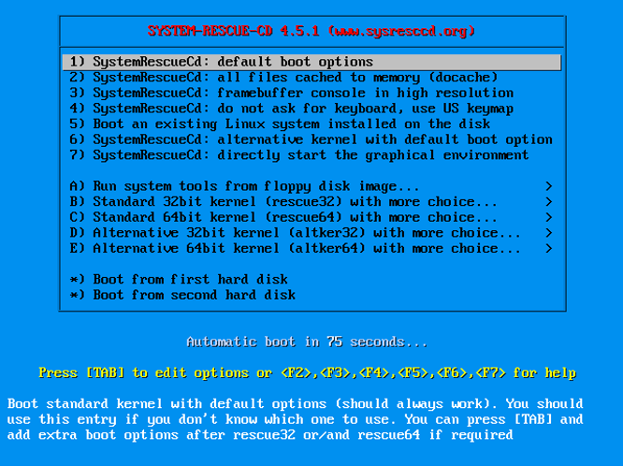

If you use the default, you see the screen below, which has some instructions followed by a command prompt. Since many modern PCs don't put Windows on partition 1 of the first hard disk, I recommend that you ignore the note on how to mount a Windows partition and proceed directly to the graphic environment by typing “startx”.

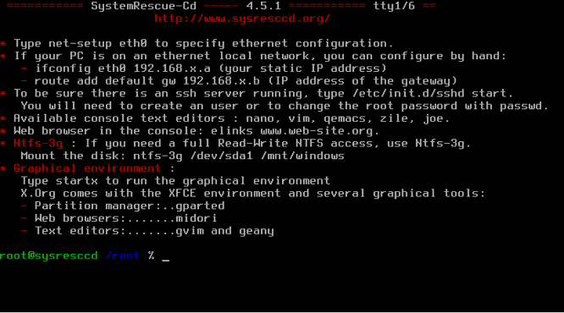

The graphical interface is quite simple. The large yellow windows has a command line; you of course can close this if you don't need it. The two smaller windows resulted from clicking on the main menu button, at the far left of the menu bar, and then selecting System. This shows some of the more useful commands available with graphical user interfaces.

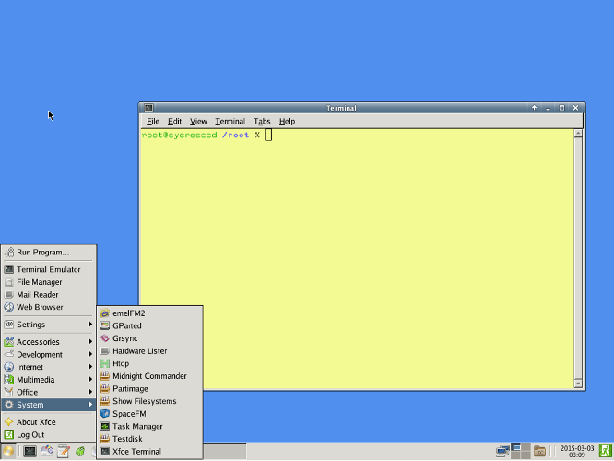

As usual, the first task is to mount the files systems of the PC you are repairing, and the easiest way to do that is with the Space file manager (SpaceFM on the menu above). When you do this and then select the disk icon in its menu bar, the presentation in the screen-shot below results.

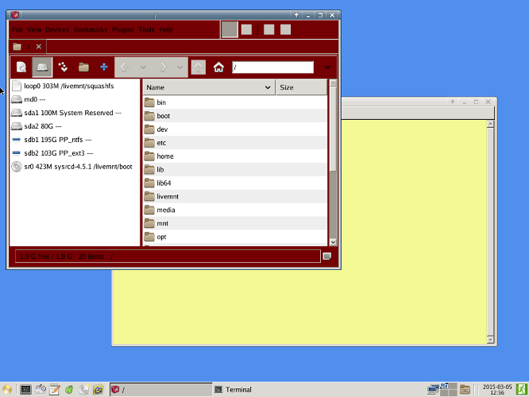

Here we are interested in only two partitions, sda2, which contains the Windows filesystem, and sdb1, an NTFS partition on a USB drive where we will copy any files we want to save. (This is a Linux system, and it uses the Linux convention for device names, where sda is the first hard disk, and its partitions are labelled sda1, sda2, and so on. Similarly, the second hard disk is sdb. On this PC Windows refers to sda2 as C:, and sdb, an external USB drive, would probably be called D:.) The next screen-shot show the result of double-clicking on these two partitions. Note that the icon for sda2 has changed from a disk to a folder and that of sdb1 from a minus to a plus, showing that the two partitions are now mounted and their contents are accessible.

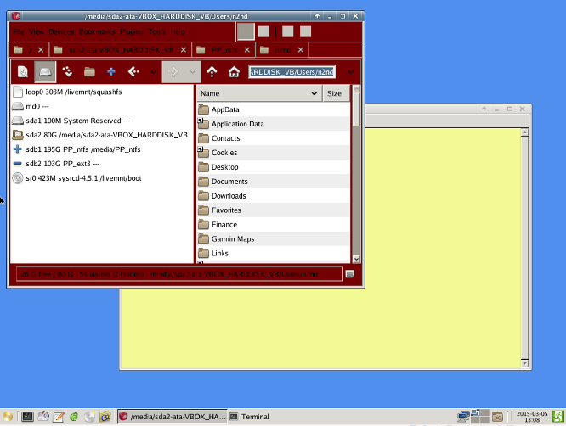

You could continue to use the Space file manager or go to the emel file manager, whose two panes ease file transfers. The next shot assumes you've done the latter and shows my home Windows directory on the left and the NTFS partition of the USB drive on the right. Preserving your home directory is always a good precaution before you attempt to repair any system.

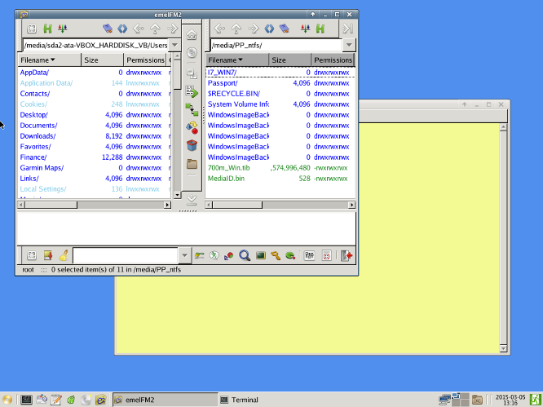

The Rescue Disk contains the very useful partition tool, Gparted, which you can use to create, delete, resize, format, and label partitions. The right side of the menu bar allows you to select a device and then shows what is selected (in this case sda). The lower portion of the screen shows all the partitions on the selected device. In this case sda2, the Windows C: partition has been selected. You must unmount a partition before you can work on it, but this can be done conveniently from within GParted.

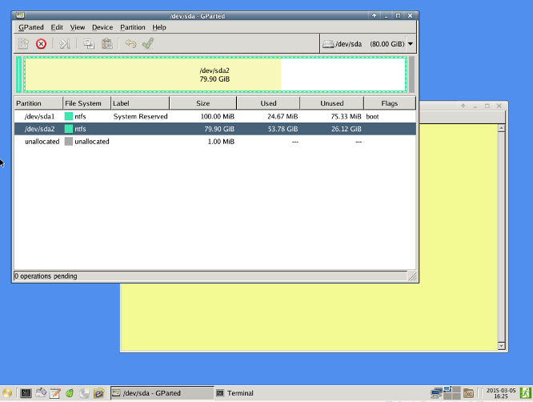

The suite of tools also includes graphical editors, a Web browser, an e-mail client, a pdf viewer, and a CD-ROM burner.

Besides these graphical interface tools, SystemRescueCD has many command-line utilities, including the following:
- sfdisk – a partition table tool to save and restore partition tables to or from a file,
- FSArchiver – a filesystem tool to save the contents of a file-system to a compressed archive file and to restore it to a different-sized device, including cloning NTFS partitions,
- Partimage – disk-imaging software, useful for backups and hard drive recovery,
- TestDisk – recovers lost partitions and repairs unbootable systems by repairing boot sectors and recovers deleted files, and
- PhotoRec – data recovery software focused video, photos, documents and archives.

As is true for most operating systems derived from Unix, documentation on the command-line is accessed using the man command. More detailed information is available on the SystemRescueCD Website, which (assuming you are working on a PC with Internet access) you can access with the included Midori Web browser. The screen below shows the first page of the on-line manual.

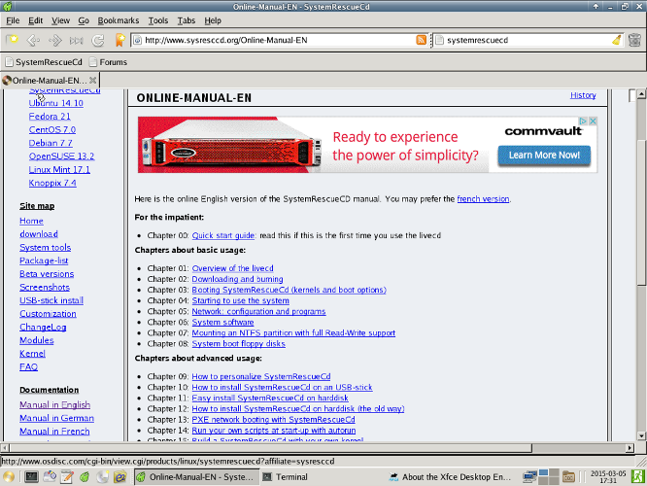

In comparison to the Trinity Rescue Kit, the SystemRescueCD is much more comfortable for Windows users because of its graphical interface, and GUI tools, including a partition editor, file managers, and Web browser. However, TRK has much better virus tools, and its manual doesn't require Internet access. Which of these provides the better solution depends on the problem you're facing. You probably should include both of these in your toolkit, and perhaps also PartedMagic. (See the references in last month's article to PartedMagic.)

Even though you are a careful and knowledgeable PC user, many of your friends and family are not, and they probably look to you for help with their frequent computer problems. Having a suite of repair tools on hand and knowing how to use them could be very helpful and save you a lot of time and anguish when someone needs your help.

